**Unit 10 Database Development**

**Tools and techniques used in a database 1**

Inside each database table is a series of records. Each record is divided into a set of fields that form the structure of the table. Each filed stores a particular piece of information about each record in the table.

**Table and record structures**

An example of a table is shown below. This shows a vehicle table for a car retail business. It has 7 records and four fields. Each record is a row in the table and each field is a column in the table.

**Field characteristics and validation rules**

When you create a database table, you assign a data type (a characteristic) to each field. Common data types are text, numeric, currency, date/time and yes/no. Choosing the right data type helps to validate the input of information into the table. For example, you cannot type text into a numeric field. In addition, you impose certain validation rules for each field. For example, if you extended the table below to include a field for mileage of the vehicle, you might add a rule to check that the value in this field is always positive, since a vehicle cannot have travelled a negative number of miles.

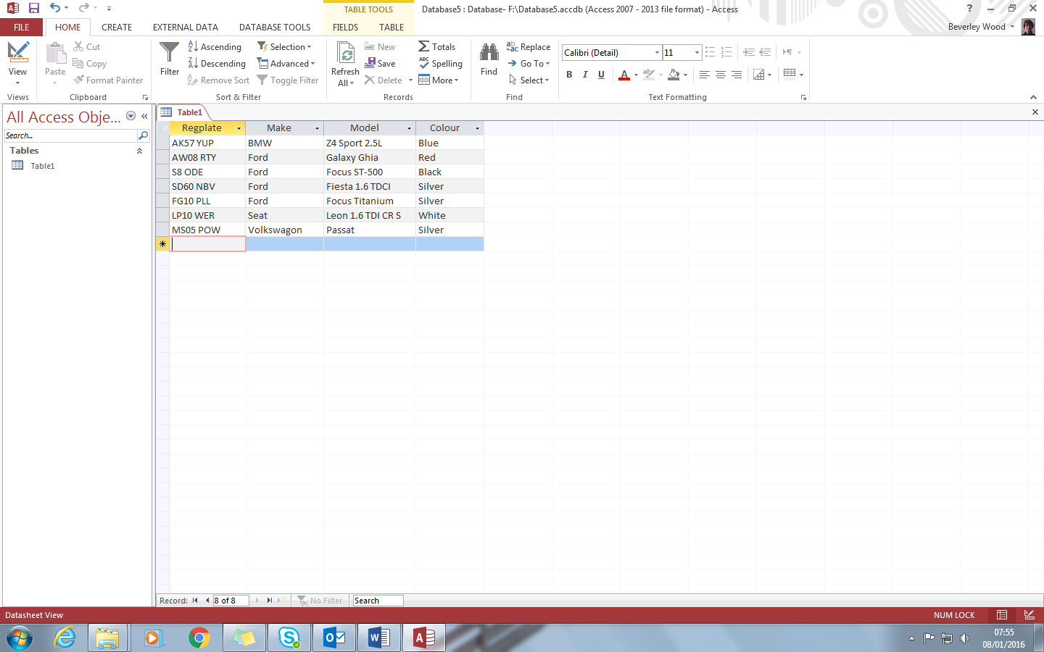

**Primary keys**

In order for relationships to be created between tables, each must have a Primary Key and a Foreign Key.

Each record in the table must be distinct. No two rows can be the same or there could be confusion about which record you are accessing or updating. For this reason, the table requires a unique field (attribute) called the Primary Key. In most cases, the primary key is a single field. Sometimes there will be a natural choice for the primary key, for example, the vehicle registration number. Where there is no unique field for each record, designers often choose a new field and set it to be the auto number data type, so that each new record gets a primary key value which is the next in a numeric sequence.

If an organisation already uses a particular combination of letters or numbers to uniquely identify records, such as a product code or student ID number, then it makes sense to use this as the primary key. This field will immediately be recognised and understood by people inside and outside the organisation.